Experimental Coral Reef Mesocosms Enriched In Macroalgae Exhibit Microbialization.
Keanu Rochette-Yu Tsuen, Laurel Diaz, Kiran Reed, Rayna McClintock, Nyssa Silbiger, Craig Nelson
University of Hawai’i at Mānoa
California State University Northridge

Abstract (150-250 words)
Bacterioplankton plays an essential role in the recycling of dissolved compounds in oligotrophic coral reefs, which support coral growth, productivity, and biodiversity in coastal tropical regions. In the recent decades, coral reefs have exhibited declining coral cover with concomitant increases in macroalgae. Continuous benthic surveys from the Moorea Coral Reef Long Term Ecological Research program illustrated that past predator outbreaks (Acanthaster planci), cyclones, marine heatwaves, and ongoing anthropogenic impacts are associated with phase shifts from coral to macroalgal dominance. The microbialization hypothesis proposes that phase shifts alters the benthic organic exudation, disrupting bacterioplankton community composition by favoring the growth of copiotrophic bacteria. Copiotrophes are less efficient at recycling carbon which causes carbon loss to higher trophic levels, decreased nutrient availability for coral primary production and growth, decreased dissolved oxygen, and increased risk of infection from potential pathogen growth. To test this hypothesis we designed mesocosm experiments simulating pre-disturbance (coral-enriched), post-cyclonic (crustose coralline algae-enriched), and post-marine heatwave (macroalgae-enriched) reefs to assess the effects of benthic communities on compositional dynamics of microbial communities and dissolved organic matter. We measured a suite of parameters over a 24h period to resolve how changes in benthic communities composition will alter dissolved organic matter composition and concentration (via fluorescence spectroscopy and high-temperature catalytic oxidation) and shift microbial community abundance and taxonomic structure (via flow cytometry and amplicon next generation DNA sequencing). Algal enrichment in benthic communities depleted nutrients, specifically nitrate+nitrite. Increased macroalgal abundance was also associated with the exudation of compositionally different fluorescent organic molecules, such as Coble C peak and fulvic acid, and resulting in changes in humic ratios (M:C ratio). Additionally, algae-enriched mesocosms exhibited greater abundant of heterotrophic bacteria with enrichment in copiotrophic genera such as Vibrio, Arcobacter, Neptuniibacter, and Roseobacter, while oligotrophic genera (Prochlorococcus, Marinimicrobia, Actinomarina, and Pelagibacter were depleted. The results of this project enhance our understanding of the interactions between coral reef benthic assemblages, bacterioplankton communities, and microbial processes, with implications on coral reef productivity, health, and resilience in the oligotrophic ecosystems of the South Pacific.

Introduction

Ecological Phase Shifts in Coral Reefs Worldwide
Coral reefs are dynamic tropical ecosystems that provide essential ecosystem services. Scleractinian corals form complex three-dimensional structures that provide habitats to diverse species of marine fauna and flora. Wave energy is rapidly dissipated in as a result of benthic rugosity which provide shoreline protection. Coastal communties have been relient on coral reefs as a source of sustenance since times immemorial with a recorded X% of the seafood consumed in nearshore communities each year in modern days. In indigenous coastal communities, where the marine environment has an intrisic spiritual and religious significance, marine resources have been used for cultural ceremonies, such as cleansing and forgiveness rituals. Coral reefs also represent a competitive economic asset as coastal areas have developed nautical activities for leisure and tourism, as well as the exploitation of fisheries for economic revenue (fish, sea urchins, pearl production etc...).
Anthropogenic disturbances are linked to coral reef degradation, resulting in phase shifts towards algal dominance (Bruno & Selig, 2007; Done, 1992).. Over the past decades, coral reefs have been in steady decline due to a combination of local and global factors. At the local-scale, proximity to human settlements has been correlated with greater algal cover in coral reefs (Barott et al., 2012). Land development, urbanization, and stream diversions have been linked to the loss of permeable surfaces, native forests, and the shortning of stream beds increasing run offs and sediment inputs in streams. Agricultural fields near the coasts or along large rivers are a source of pollutants such as pesticides, herbicides, and fertilizers in the aquatic systems. As a result, terrestrial run offs increased sedimentation and represent non-point source pollution in coastal waters which collectively, increase the sensitivity of corals to envrionmental pressures, further weakening the resilience of coral reefs. (Adam et al., 2021; McCook, 1999; Smith et al., 2006) (Bahr et al., 2015; Jones et al., 2019). Additionally, the over-exploitation of marine resources has caused detrimental ecological consequences on marine ecosystems. Chronic overfishing reduces grazing pressure on macroalgae and/or reduces top-down control on corallivorous fish which supports the proliferation of macroalgae in coral reefs (Carpenter, 1986; Lewis, 1986; Miller, 1998; Miller & Hay, 1998). Alteration of trophic dynamics had rippling effects on the marine food webs, i.e. trophic cascades, which can result in the collapse int the population of marine food sources without proper management.
At the global scale, sustained anthropogenic carbon emissions increase the frequency and intensity of detrimental stochastic events. Extreme events such as marine heatwaves, storms, and hurricanes can drive large scale coral mortality, which promote conditions ideal to induce coral-algae phase shifts (Glynn, 1993; Glynn & D’croz, 1990; Hoegh-Guldberg, 1999; Kleypas et al., 1999) (Edmunds et al., 2025; Palmer et al., 2025; Schmitt et al., 2019). Shifts in oceanographic regimes from global warming have also increased the frequency and intensity of cyclical events such as El Niño events which can induce large-scale bleaching and intense hurricanes resulting in additional coral mortality (Palmer et al., 2025). The degradation of coral reefs will only get more severe as a result of the combined effects of local pressures and climatic events, thus increasing the likelihood of ecological phase shift from coral to algae dominance in tropical reefs. Large scale alterations in coral reef bethic community assemblages have documented effects on the ecosystem functions of macro flora and fauna (Ainsworth & Mumby, 2015; Carpenter, 1986; Done, 1992; Trapon et al., 2011). However, the effects of phase shifts on water column processes have limited resolution and have potential implications on ecosystem productivity, health, and functions.

Effects of Organic Exudation of Benthic Primary Producers on Microbial Carbon Processing
Coral-algal phase shift changes the benthic community assemblages with consequences on carbon processing. Coral and macroalgae exude part of their primary production in the form of dissolved organic matter (DOM). Representing a rather large pool of carbon the ocean, DOM can be measured by proxy in the form of dissolved organic carbon (DOC) or fluorescent dissolived organic matter (fDOM). Labile DOM constitute the base of microbial food webs and microbial processes support coral reef productivity. The microbial loop recovers DOM and cycles it back into the food web, thus preventing carbon loss to the environment. Due to nutrient limitation in oligotrophic tropical oceans, microbial remineralization of DOM ensures the access of biologically available inoragnic nutrients to primary producers. As such, microbial process are essential in maintaining productivity, ecosystem function and biodiversity in coral reefs.
DOM exhudation and composition varies between corals and macroalgae. Benthic primary production represents a source of dissolved organic matter (DOM) in the water column with greater dissolved organic carbon (DOC) fluxes associated with algae compared to corals (Brocke et al., 2015; Haas et al., 2011, 2013). In isolation, macroalgae exuded magnitudes of DOC more compare to corals and were associated with distinct pools of DOM (Haas et al., 2013; Nelson et al., 2013). DOM associated with macroalgal communities showed enrichment in labile carbohydrates (galactose and fucose), while coral exometabolites were enriched in aromatic amino acid molecules (Nelson et al., 2013; Quinlan et al., 2018). Exudates of benthic primary producers influence microbial metabolism and microbially-mediated processes (Wegley Kelly et al., 2021). Algal exudates are rapidly consumed by heterotrophic microbes, resulting in greater growth rate, bacterial activity and abundance (Haas et al., 2011, 2016; Nelson et al., 2013; Quinlan et al., 2025). As a result, algae exudates were associated with greater abundance of microbes and distinct commmunity strutures compare to corals. Further investigation at the ecosystem level showed that corals and macroalgal produce exometabolites that are compositionally different in chemical classes and stoichiometry (Wegley Kelly et al., 2022).
The microbialization hypothesis suggests that coral-algal phase shifts would shift reef metabolism to microbial consumption and energy use. As corals and algae photosynthesize, they release different quantities and compositionally distinct pools of DOM, therefore feeding different taxa of microbes. This is thought to affect microbial proccesses which maintain productivity and health in coral reef ecosystems. However, despite rapid carbon consumption, algal exudates are associated with reduced microbial growth eﬀiciency which limits carbon recycling through the microbial loop with repercussions on abundance and biodiversity of higher trophic consumers (Nelson et al., 2023; Silveira et al., 2015).

Exudate Composition Influences Microbial Community Structure
In oligotrophic coral reefs, exudated dissolved organic matter (DOM) constitutes the base of microbial food chains and bacterioplankton plays a critical role in the remineralization and trophic recycling of these dissolved molecules (Nelson et al., 2013; Tanaka et al., 2011; Wild et al., 2010). The analysis of metagenomic taxonomy of the 16S rDNA gene reveals that water column bacterial communities are coupled with the benthic ecosystem via DOM exudation. Evidence suggests that microbial community structure changes in response to variation in DOM composition, quantity, and quality, with repercussions on microbial diversity and abundance (Quinlan et al., 2018; Sparagon et al., 2024; Weber et al., 2022). Coral exudates have been associated with oligotrophic taxa, specifically, Alphaproteobacteria families (Erythrobacteraceae, Kordiimonadaceae, Hyphomonadaceae) (Haas et al., 2016; Nelson et al., 2013). On the other hand, algal exudates exhibit a greater association with copiotrophic taxa, e.g., Gammaproteobacteria families (Enterobacteriaceae, Vibrionaceae, and Pasteurellaceae) and Bacteroidetes (Cytophagaceae and Flavobacteriaceae) (Haas et al., 2016) some of which have a higher likelihood of carrying bacterial virulence factor genes (Nelson et al., 2013). As a result, alteration of bacterial communities could impact microbially-mediated carbon remineralization, nutrient recycling, and biomass transfer to higher trophic levels, with repercussions on coral feeding, photosynthesizing, calcifying, and pathogenesis (Morrow et al., 2012; Nelson et al., 2023).
------ Intergrate in section above -----
Interactions between the coral reef benthos, carbon fluxes, and bacterioplankton remain poorly understood in mixed benthic communities. Previous studies either used mesocosm experiments with isolated benthic organisms to measure the organic exudation and microbial metabolism (Brocke et al., 2015; Haas et al., 2011; Nelson et al., 2013), or in-situ surveys to associate net organic matter release and microbial communities in the coral reef ecosystem (Comstock et al., 2022, 2026 ; Haas et al., 2016 ; Nelson et al., 2011). Links between benthic primary producers and reef microbial metabolism have been investigated in lab and in situ measurements on isolated individuals (Haas et al., 2013). However, the effects of mixed benthic community assemblages on organic outputs, microbially mediated processes, and bacterial community structure in coral-algal phase shift conditions have not yet been tested.

1.X Caveats of current studies
However, current studies, specifically the seminal paper that do attempt to resolve the biogeochemical and microbial changes associated with phase shift, are not representative of the natural reef conditions. Indeed, Haas 2013 and Nelson 2013 have demonstrated DOC differences in quantities and composition leading to microbial community changes in incubation experiments of isolated individuals. This study does not encompass the complexity of coral reef ecosystems and does not account for diverse species assemblage/inter-species contribution of the DOM pool, thus providing a limited understanding of DOM exudation and microbial dynamics. Conversely, Haas 2016 compares different coral reefs systems in different oceans and on different territories resulting in potential confounding variables due to differences in oceagraphic regimes, variability of sampling, seasonilty and time passed between sampling compaigns…etc. In order to understand the specific changes associated with coral-algal phase shifts, we need better controlled conditions with reefs that are directly comparable, which can be achived by artificially recreating reef ecosystems in mesocoms.

Mo’orea Coral Reefs: a Case Study of the Effects of Benthic Community Alteration on Coral Reef Biogeochemistry
The island of Mo’orea, French Polynesia, represents an ideal location to address the gap in knowledge regarding coral-algal phase shifts induced microbialization. Decadal benthic surveys from the Mo’orea Coral Reef Long Term Ecological Research program (MCR LTER) have shown that reefs have exhibited a series of shifts in dominant benthic taxa with partial recoveries throughout its history (CITATION !). Long term surveys enabled the development of a well-informed hypothesis on the etiology of the coral-algal phase shifts occurring in Mo’orea: 2006 predator outbreaks of Acanthaster planci (Crown-of-Thorns seastar or taramea), 2011 cyclone Oli, and the 2019 marine heatwave (Kayal et al., 2012; Schmitt et al., 2019). Additionally, nearshore nutrient enrichment (John et al., 2025) and overfishing may facilitate macroalgae growth in their competition for space against corals (Adam et al., 2021; Schmitt et al., 2019). Understanding the implications of coral-algal phase-shifts in Moorean reefs would provide invaluable indights on the mechanistic onsets of microbialization, the magnitude of the biogeochemical changes, and the resilience of the ecosystem.

Project Objectives
In this project, we sought to understand the effects of the enrichment of selected primary producer taxa in mixed benthic assemblages on organic exudation and composition with subsequent effects on bacterioplankton abundance and community structure. We hypothesized that DOC production would be significantly greater in communities enriched in macroalgae with compositionally distinct DOM outputs. Consistent with the microbialization hypothesis, we expected to observe distinct bacterial communities associated with algal enrichment, with greater abundance of copiotrophic bacterial families. Additionally, inorganic nutrients (ammonia, nitrate, and phosphate) are hypothesized to be more depleted in algal communities, especially during the daytime, due to increased nutrient uptake associated with primary production.
To test these hypotheses, we designed a large-scale flow-through mesocosm experiment tracking dynamics of organic matter and microbial communities among reef assemblages representative of benthic community types found over the past two decades on the North Shore of Mo’orea: pre-disturbance (coral-enriched) communities were contrasted with parallel post-cyclonic (crustose coralline algae-enriched), and post-heatwave (macroalgae-enriched) communities. Over a 24-hour period the water column of these mesocosms was sampled every 6 hours to investigate coupled changes in organic exudations, bacterial abundance, and bacterial community structure. Results illustrate the effects of mixed communities on organic exudation, carbon processing, and microbial community dynamics with respect to the phase shift induced microbialization.

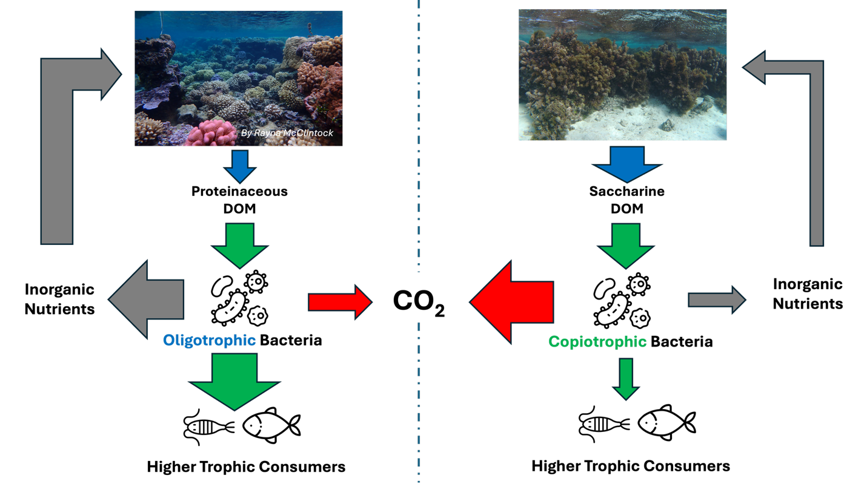
Figure 1: Hypothesis schematic

Methods and Materials

Site Description Overview
Mo’orea is a small volcanic high island (135 km²) located in the Society Islands of French Polynesia (17°30’S, 149°50’W) in the South Pacific. The island is surrounded by an extensive coral reef barrier, roughly 0.5 kilometer from shore, through which 12 reef passes allow seawater to flow between the lagoons and the open ocean. The inner side of the reef barrier represents a distinct shallow back reef habitat (about 3 m deep) where reef patches, separated by sand, coral rubble, and reef pavement, dominate the benthos (Leichter et al., 2013). In this study, we aim to characterize the biogeochemical and bacterial community changes associated with altered benthic ecology. Using benthic cover time series from the LTER program, we identified three ecological phases: a coral-enriched pre-disturbance reef (2006), post-cyclonic crustose coralline algae (CCA)-enriched reef (2011), and a post-marine heatwave algae-enriched reef (2019). We experimentally recreated the 2006, 2011 and 2019 reef assemblages, representing 3 treatments, in flow-through mesocosms using coral fragments, CCA, algae, sand, and coral rubble from the North shore back reef habitats of Mo’orea.

Benthic Organism Collection for Mesocosm Communities
Benthic organisms, especially corals, crustose coralline algae and macroalgae Turbinaria ornata were collected under permit # XXXXX in the back reef of the North shore of Mo’orea, in the Papetō’ai district (17°29’09.0”S, 149°52’42.6”W). Porites rus coral fragments, Turbinaria ornata, crustose coralline algae (CCA) (Porolithon onkodes and Hydrolithon sp.), coral rubble, and sand were collected on snorkel at 3 m depth. P. rus colonies (~15 cm in diameter, n = 24), Porolithon onkodes and Hydrolithon sp. were collected using a hammer and chisel. Whole T. ornata (~20 cm tall) was collected by hand at the substrate level (n= 52). Additionally, sand was collected using a hand trowel and bucket from the top 5 cm oxic layer of sediments. Samples were brought back in coolers to the Gump South Pacific Research station, located in Piha’ena, Mo’orea. The Gump Station is a University of California research station supported by the Long-Term Ecological Research (LTER) program which provides the necessary facilities for US researchers to conduct studies in French Polynesia.

Mesocosm Experiment Set Up
Mesocosms comprised of 11.4-liter clear polycarbonate aquaria (27.62 cm x 27.62 cm x 20.32 cm) that were previously leached in DI-water for 24h. Two holes were drilled into the side of the aquaria, about 13 cm apart, fitted with PVC pipes and nozzles that were fixed with PVC cement. PVC valves on each water outlet allowed measurement and control over the flow rate of the out-going water. Water flow rate was adjusted every five days by measuring the volume of water flowing out of the tank for a minute. Average outgoing flow rates of the aquaria were 5.86 ± 6.00 mL.s-1 for a mean aquarium residence time of XX. Aquaria were placed in flow through water tables equipped with overhead pipes to supply seawater from Paopao Bay (Cook’s Bay). Mesocosms aimed to recreate benthic cover of the reefs of Moorea based on 2006, 2011 and 2019 LTER data. The 2-dimensional planar benthic cover of the mesocosms was manipulated to replicate the percent cover recorded in the LTER time series fromt the years 2006, 2011, and 2019. Coral-enriched aquaria represented a pre-disturbance state (44% coral, 34% rubble, 18% sand, 2% CCA, 2% Turbinaria). CCA-enriched tanks represented reefs post-Acanthaster planci outbreak and post-cyclonic disturbance (15% coral, 34% rubble, 25% sand, 25% CCA, 1% Turbinaria). Algae-enriched aquaria represented contemporary conditions (5% coral, 55% rubble, 20% sand, 0% CCA, 20% Turbinaria) (Figure 1). In addition to our three benthic cover treatments, a seawater-only mesocosm was used as a control to distinguish natural seawater chemistry shifts from those caused by benthic assemblages. Sixteen independent mesocosms were randomly assigned to each of the 4 treatments among two flow-through seawater tables, each connected to an overhead supply line that provided seawater to individual mesocosms through separate tubing. Flow-through tables were located in a partially shaded mesocosm facility at the UC. Berkeley Gump Research Station. Circulation pumps (600 L/H) were placed in each aquarium to ensure water circulation and avoid deoxygenation.

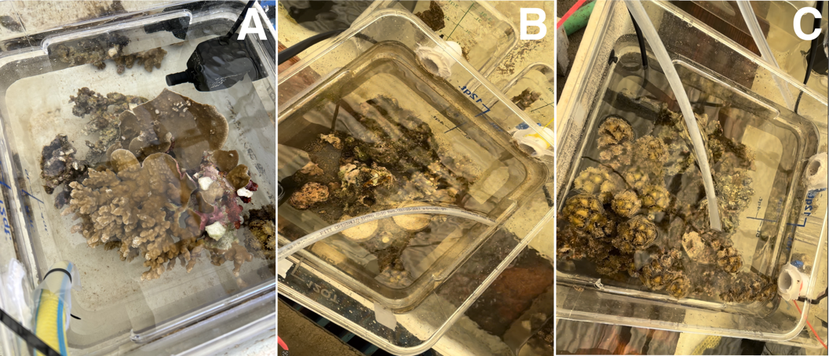
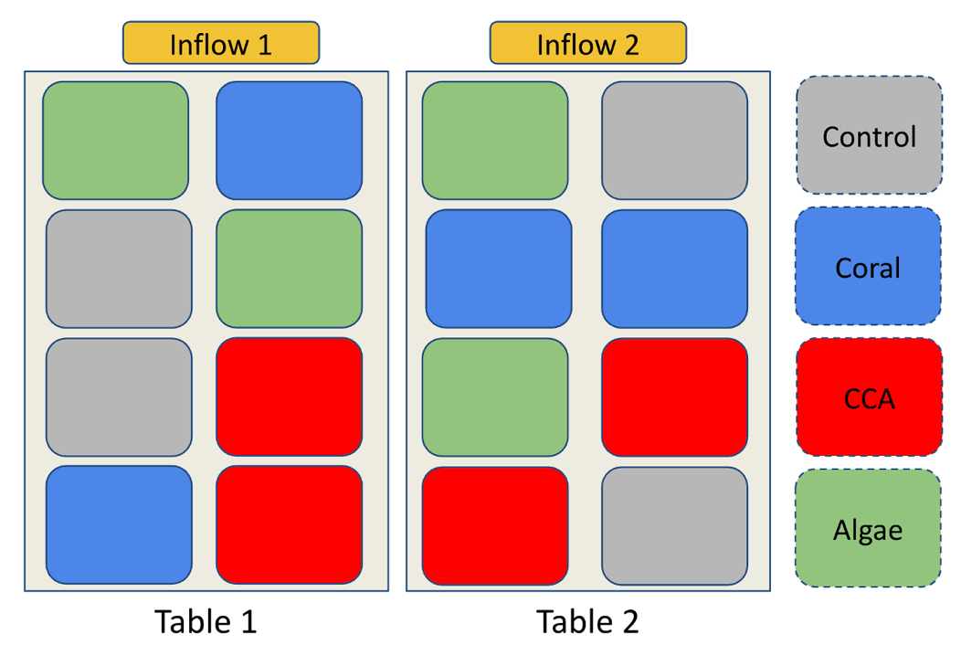
Figure 1: Mesocosm Experiment Setup.
(Top) Mesocosms containing benthic communities enriched in coral [A], crustose coralline algae (CCA) [B] and macroalgae [C]. (Bottom) Disposition of the 16 mesocosms on flow-through water tables.

Water Sample Collection
Throughout this experiment, we aimed to establish a comprehensive biogeochemical profile of the coral reef communities when exposed to our treatments. Using acid washed 1L polycarbonate bottles, we collected bulk water samples from the mesocosms every 6 hours over 24-hours, from June 2, 2024, 12:00 to June 3, 2024, 06:00 during the Austral winter. Various analytical subsamples were subsequently partitioned from these collections with different storage and preservation conditions. Each bottle was assigned to a specific mesocosm and only collected water from that aquarium. Bottles were triple rinsed with mesocosm water before bulk water collection. Water samples were also taken from the inflow pipes (the two water tables each had an independent overhead central inflow pipe from which water lines were connected to supply water flow to the mesocosms). Bulk water sample bottles collected from each aquaria were filtered via a Golander DG 6-12 peristaltic pump with pharmed peristaltic inserts and platinum-cured silicone transfer tubing; all tubing was acid leached and sample rinsed before collections. Subsamples were collected for dissolved organic carbon (DOC), fluorescent dissolved organic matter (fDOM) indices, nutrients (total nitrogen, nitrate, nitrite, ammonia, silicate and orthophosphate), water column chlorophyll-a, bacterial abundance, and bacterial metagenomic taxonomic structure.

Subsample Collection and Laboratory Analysis

Dissolved Organic Carbon (DOC)
Subsamples for DOC were pumped through 0.7µm, 25mm diameter Sterlitech Type F glass fiber syringe filters. Water lines were acid washed before filtration and were rinsed with mesocosm water before sample collection. Filtered water was stored in precombusted 24mL borosilicate vials, triple washed with filtrate, and acidified with hydrochloric acid (HCl 10%), then stored in the dark at room temperature. Samples were processed at the School of Ocean and Earth Science and Technology Laboratory for Analytical Biogeochemistry (S-LAB), University of Hawai’i at Mānoa. DOC was measured using a Shimadzu TOC-L Combustion Analyzer (detection limit of 4µg/L) via high-temperature catalytic oxidation using methods from (Carlson et al. 2010). A set of 8 DOC samples collected at midnight between 02 and 03 June 2024 were extreme statistical outliers greater than 2 standard deviations (70 µM) above the experimental mean (140 µM; n= 72) and were excluded due to contamination; other parameters collected at these timepoints were not outliers and were retained in the dataset.

Fluorescent Dissolved Organic Matter (fDOM) and Nutrients
Using the same pumping system, the Golander DG 6-12 peristaltic pump was aﬀixed with 0.22 µm Sterivex-GP pressure filters (Millipore Sigma). Filtered water for fDOM and nutrient measurement was collected in 50 mL polypropylene centrifuge tubes, triple-rinsed with filtrate prior to sample collection, and stored at -40°C. Samples were thawed 12 hours prior to fDOM measurements to allow them to come to room temperature. 1 cm quartz cuvettes were triple washed with DI water and wiped dried with Kim wipes. 3 mL of sample water was aliquoted in the cuvette and placed in a Horiba Aqualog scanning fluorometer. The cuvettes were triple rinsed with DI water in between samples. Samples were measured in groups of 7 with a DI water blank measured in-between groups. Data processing was performed using methods and scripts from Nelson et al. (2015). Excitation-Emission matrices (EEMs) were generated using excitation values every 5nm from 240nm to 500nm, and emission values measured continuously via CCD ranging from 250 nm to 825nm integrated over 4 sec at each excitation increment. Inner filter correction was applied to account for fluorescence quenching by absorbance (Kothawala et al., 2013). Fluorescence values were divided by the integrated emission range of 381nm to 426nm at an excitation of 350 nm in averaged DI water blanks to scale the measurements to Raman Units (Lawaetz & Stedmon, 2009). An average blank EEM was calculated from DIW blanks run before and after each set of samples and subtracted from each set of 7 sample EEMs. Lastly, informative biogeochemical indices were calculated, such as, UV-Humics (Coble A), Visible-Humics (Coble C peak), and tryptophan-like (Coble T) (Coble, 1996), fulvic acid (FI) (McKnight et al., 2001), and humic indices (BIX and HIX) (Huguet et al., 2009). After the fDOM measurements, water samples were returned to the freezer for storage at -40°C before being used for nutrient measurement. Nitrate plus nitrite (detection limit 0.006 µmol/L), orthophosphate (detection limit 0.012 µmol/L), silicate (detection limit: 0.116 µmol/L), and ammonia (detection limit 0.013 µmol/L) were measured with UV detection using the SEAL AA500 segmented flow injection nutrient analyzer following methods from (Kealoha et al., 2025).

Chlorophyll-a
The peristaltic pump was fitted with 0.45 µm HAWP nitrocellulose filters (MF-Millipore) and 250 mL sample water was filtered. The filters were frozen in aluminum foil at -40°C in the field lab, then stored -80°C for long term storage at the University of Hawai’i. The chlorophyll was extracted from the thawed filters by dissolving the filters in 5mL of 90% acetone for 6-8h in borosilicate vials. During the dissolution period, the capped vials were stored in the freezer. Samples were allowed to warm to room temperature 30 min before measurements. Chlorophyll-a fluorescence was measured using the Turner Design 10 AU fluorometer. Acetone solutions were loaded in the fluorometer to measure fluorescence at 680 nm. Final chlorophyll-a concentrations were calculated using the calibration curve of the SLAB which accounts for the filtrate and solvent volumes.

Cell Abundance via Flow Cytometry
1 mL of mesocosm seawater was sampled using a pipette with disposable tips and fixed with paraformaldehyde for a final concentration of 0.5% v/v in 2ml screw cap centrifuge tubes and kept at room temperature for 1-2h until being flash-frozen at -40C with subsequent long-term storage at -80°C at the University of Hawai’i for long term storage. Samples were processed at the Biological Electron Microscope Facility (University of Hawai’i at Mānoa) using a Beckman-Coulter CytoFLEX S flow cytometer. Once thawed and brought to room temperature, 275 µL samples were aliquoted to polystyrene 96-well U-bottom plates and stained with 7µL of Hoescht 34580 dye (40µg/µL) for a final concentration of 1µg/µL. Additionally, distilled water blanks (stained and unstained) were added to each sample run. Samples were kept in the dark to stain for 30 min prior to being analyzed in the flow cytometer as per Selph (2021). Samples were drawn from each well at a rate of 60µL/min for 75 seconds, excluding the events of the first 15 sec to avoid cross-contaminations between wells.
Cell count was determined via hierarchical gating which separated events by size, DNA stain, and pigment-associated autofluorescence. The first gating separated the events in “low” and “high” chlorophyll content. Background events were determined by comparing bacterial counts in samples and blanks, and then removed from the sample events. Low-chlorophyll events were classified as heterotrophic bacteria while high-chlorophyll events were further divided by forward scatter. Large high-chlorophyll events were categorized as pico-eukaryotes while smaller events were labeled as picocyanobacteria. Cyanobacteria were sorted by phycoerythrin (PE) content with high PE cyanobacterial events corresponding to Synechococcus, and low PE cyanobacterial events were labeled as Prochlorococcus. Cell density (gated events per µL) was calculated by standardizing the event counts to the volume processed included in the event gating (60 µL).

Bacterial Community Structure
Sterivex filters used to collect nutrient and fDOM samples were frozen dry at -40°C in the field laboratory, then subsequently returned to the University of Hawai‘i and stored long term at -80°C. The 0.22 µm polyethersulfone filters were retrieved aseptically from the casing and placed in bead tubes (MP Biomedicals FastDNA™ Garnet Matrix). DNA was extracted at the University of Hawai’i Microbial Genomics and Analytical Laboratory (MGAL) using a Machery-Nagel NucleoMag microbiome kit on a ThermoFisher KingFisher Flex system. The V4 region of the 16S rRNA gene amplification following protocols from the Earth Microbiome Project (Caporaso et al., 2018) using forward-indexed primers 515F-Parada (5’-GTGYCAGCMGCCGCGGTAA-3’) and 806R-Apprill (5’-GACTACNVGGGTWTCTAAT-3’) (Walters et al., 2016). Minor modifications to the protocols were made such that triplicate reactions were not pooled and a standardized volume of 1µL of genomic template was used for amplification. The SequelPrep kit (Thermo Fisher Scientific) was used to clean and normalize the amplicons to equimolar concentrations. Samples were then pooled and sequenced using the Illumina MiSeq platform (600 cycle V3 chemistry). Sequences were demultiplexed using a probabilistic script; microbiome profiling was executed through the MetaFlow|mics pipeline (Arisdakessian et al., 2020) using settings from Jani et al. (2021). Sequences were assembled, denoised and trimmed using DADA2 and aligned with mothur to the Silva(v132) global SSU rRNA alignment database (Callahan et al., 2016; Schloss et al., 2009; Yilmaz et al., 2014). We used bayesian consensus classification to assign taxonomy strings to the sequences (70% confidence) to the genus level, and clustered into 97% sequence identity operational taxonomic units (OTU) using VSEARCH (Rognes et al., 2016; Wang et al., 2007). OTUs were refined to reduce intragenomic taxonomic splitting errors using LULU (Frøslev et al., 2017). Sequences that could not be classified at the “Domain” level as well as Mitochondrial and chloroplast 16S sequences were discarded. The sequencing depth was then standardized to 10,000 random reads per sample. Bioinformatics data was processed on the C-MAIKI gateway at the University of Hawai i at Mānoa (Cleveland et al., 2022). After data processing, OTU that were not greater than 0.1% abundance in at least one sample were filtered out of the data set.

Statistical Analysis
To test the hypothesis that algal communities change DOC production, DOM composition, nutrient consumption, and bacterial abundance compared to the control, we ran linear mixed effects models with DOC, fDOM, nutrient measurements and bacterial abundance as our dependent variables. Data processing and statistical analysis were performed using R (version 4.5.2) and RStudio (Posit Software, Boston, MA) (RStudio Team, 2022). For each variable, values that were outside of the $\overline{x}±2σ$ ranges were identified as outliers. The biogeochemical measurements were relativized to the average value of the inflow at the time of sampling, i.e., for each variable, values measured at each inflow line (one directed to each of the two experimental tables – Figure 1) were averaged first, then all aquaria concentration measurements were relativized by subtracting the averaged inflow value from the aquarium measurements. Linear mixed-effect models (package lme4 in R) were run using relativized data as a dependent variable, treatments of control, coral, CCA, and algae as independent variables with a sample time interaction term, and aquaria ID number as a random effects variable to account for repeated measures. Least squares linear regression of relativized concentration against log-transformed flow rate showed no significant flow rate effects on any variables (Supplemental Table 6.1). As such, log-transformed flow rates were added as a predictor in linear mixed-effect models for robust statistical modeling. For models that had a significant fixed treatment effect, we used a Dunnett’s post hoc test to determine contrasts (Lenth et al., 2026). Figures were created using the ggplot2 and patchwork packages (Pedersen, 2025; Wickham, 2016).
To investigate the bacterial community changes, we ran a PERMANOVA model using adonis2() from the package vegan (Oksanen et al., 2026). We used the weighted Unifrac distance matrix generated from the MetaFlow|mics pipeline with treatments, sampling time point and the log10-transformed flow rate as model predictors. We also accounted for treatment-time interactions, and repeated measurements using the aquaria ID number in the “strata” argument. Bacterial community changes were visualized in NMDS plots using the vegan package. The relative abundance of bacterial genera was displayed on a heatmap created with Complex Heatmap to display enrichment patterns and to cluster bacterial taxa in modules that had similar enrichement patterns (Gu et al., 2016). Bacterial taxa were simplified to exclude rare genera which had a summed abundance less than 0.5% in at least 3 samples. The relative abundance of abundant taxa was summed in each samples, square-root transformed, and z-scored before being plotted on a heatmap. Module membership was extracted from the heatmap. The relative abundance of each module was summed in each sample and modeled statistically to understand the effects of treatment and time on enrichment patterns. To understand changes in microbial community structure, we eventually ran linear mixed-effects models and Dunnett’s post-hoc test for each bacterial genus to identify specific microbial taxa which are sensitive to the effects of treatment and time in our experiment.

Results

Inorganic Chemistry
Over the 24h experimental periods, the macroalgal treatment was associated with the depletion of nitrate (nitrate+nitrite). While there were no differences between the seawater control and the coral and CCA treatments (Dunnett’s contrasts Coral: p=0.9999, CCA: p= 0.84), nitrate was significantly depleted in the macroalgae treatments compared to the controls (ANOVA F_{treatment} = 3.81, df=3, p = 0.04, Dunnett’s contrasts p=0.04). Despite natural variabilities of nitrate concentration in the mesocosm (range of non delta values?), there was no interactions between time and treatment effects (F_{treatment:time} = 1.11, df=9, p = 0.38), suggesting the consistent depletion of nitrate in algal communities across the sampling time points. Secondarily, dissolved silicate exhibited significant depletion between the CCA-enriched treatment and seawater control (F_{treatment}= 7.15, df = 3 p<0.01, Dunnett’s contrasts p<0.01), but treatment effects varied with sampling time point (F_{treatment:time}= 3.27, df =9, p = 0.004). Measurements of dissolved silicate in CCA communities showed the most depletion at 12:00 compared to the other three time points (Tukey’s Post hoc p<0.05), followed by signifcant depletion at 06:00 compared to the 18:00, 00:00 time points (Tukey’s Post hoc p<0.05). However, there was no significant difference between the 18:00 and 00:00 measurements (Tukey’s Post hoc p= 0.95). Additionally, phosphate and ammonium did not show a significant treatment effect (p_{treatment} > 0.05). Results suggest robust evidence that benthic community compostion influences nitrate dynamics while showing moderate linkages between dissolved silicate and benthic assemblages.

Organic Matter Exudation Rates in Mixed Benthic Communities
Benthic communities exhuded different quantities of DOM and were assoiated with distinct DOM pools. Among the fDOM measurements, Coble C (Colored fDOM) was did not vary throughout the sampling period (F = 2.48, df = 3, p = 0.07) and was significantly enriched in the algal (ANOVA F= 6.05, df = 3, p = 0.01, Dunnett’s contrasts p=0.02) and CCA communities (Dunnett’s contrasts p=0.03), while coral communities did not show significant difference compared to the controls (Dunnett’s contrasts p=0.72). Other humic and proteinaceous forms of fDOM did not show signficant differences between treatments (p_{treatment} > 0.05). fDOM indices show compositionally distinct DOM pools among treatments. M:C ratio was significantly reduced in algal and CCA communities compared to the controls (ANOVA F=17.4, df=3, p<0.01; Dunnett’s contrasts Algae: p <0.01, CCA: p <0.01), while the coral communities showed not difference (Dunnett’s contrasts p = 0.33). Despite displaying variations across the sampling regime (F = 4.69, df = 3, p=0.008), there was no interactions between treatment and time effects (F= 1.49, df = 9, p = 0.19). Similarly, Fluorescence Index (FI) was signficantly decreased in algal communities (F= 4.38, df = 3, p<0.009, Dunnett’s contrasts p = 0.02) and showed no significant difference in coral and CCA communities (Dunnett’s contrasts: Coral: p = 0.40, CCA: p = 0.48) compared to the seawater controls. FI exhibited significant time effect (F= 9.63, df = 3, p< 0.01), however, there were no treatment and time effect interections (F= 0.62, df= 9, p = 0.77). On the other hand, other humic indices, such as BIX and HIX, showed no significant difference between the treatments and control (p > 0.05). Collectively, algae-enriched communities exhibited a compositionally distinct pool of humic-like exudates relative to the seawater control, independent of sampling time.

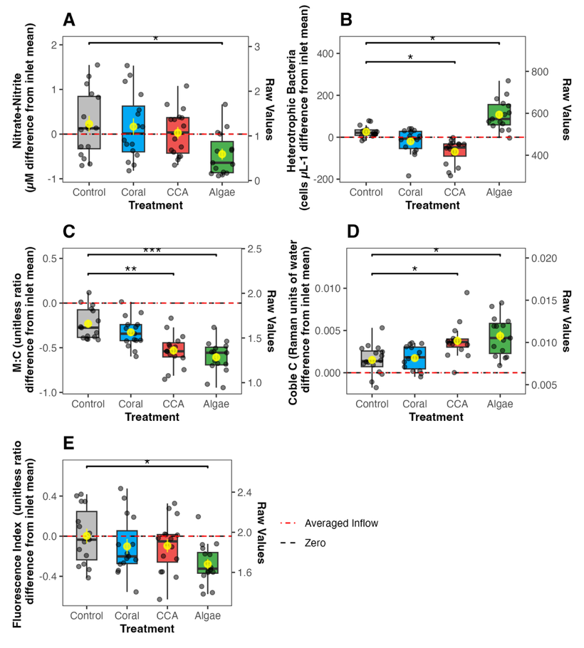
Figure 3: Exudation of fluorescent DOM indices.
fDOM exudation by treatment and across a diel cycle show increased production of Coble C and decrease measurements of FI and M:C ratio in algae-enriched communities.

Bacterial Abundance and Chlorophyll-a
Bacterioplankton measurements showed a greater abundance heterotrophic bacteria in algae-enriched community. Heterotrophic bacteria were signficantly enriched in algal communities (F= 13.9, df =3, p <0.01, Dunnett’s contrasts p = 0.04), significantly depleted in CCA communities (Dunnett’s contrasts p = 0.03), and did not significantly differ from the controls in coral communities (Dunnett’s contrasts p = 0.40). Bacterial abundance varied signficantly throughtout the experiment (F = 3.26, df = 3, p = 0.03), however there was no interactions between time and treatment effect (F= 0.86, df =9, p = 0.57), and no differences between time points (Tukey’s Post hoc p > 0.05). Therefore, heterotrophic bacteria were consistent enriched in algae-communities and depleted in CCA-communities. Synechococcus was significantly depleted in CCA-communities (F= 9.44, df = 3 , p <0.01, Dunnett’s contrasts p <0.01), while there was no signficant difference between the coral (Dunnett’s contrasts p = 0.12) and algal (Dunnett’s contrasts p =0.05) communities relative the controls. Synechococcus abundance significantly varied throughout the experiment (F = 9.84, df =3, p <0.01), with a significant increase in abundance from 12:00 to 18:00 (Tukey’s HSD test p<0.01), but there was not treatment:time interactions (F = 1.49, df = 9, p = 0.27). As a result, Synechococcus were consistently depleted in CCA-communities. Pico-eukaryotes were signficantly depleted in CCA communities (F= 4.87, df=3 , p = 0.02; Dunnett’s contrasts p=0.02) but showed no difference in coral (Dunnett’s contrasts p = 0.7) or algae communities (Dunnett’s contrasts p = 0.09) compared to the controls. Pico-eukaryotes exhibited significant time variations (F = 238.2, df = 3, p = <0.01) with significant increase from 12:00 to 06:00 (Tukey’s HSD test p < 0.01), but there was no treatment:time interactions (F= 1.2, df = 9, p = 0.33). However, differences between time points were uneven as 12:00 was signicantly different from every other time points (Tukey’s HSD test p <0.01), while 18:00, 00:00 and 06:00 showed no significant difference among one another. Pico-eukaryotes show mild evidence of depletion in CCA communities. Lastly, Prochlorococcus (F=1.49, df= 3, p=0.27) and Chlorophyll-a (F= 1.26 df = 3, p=0.33) did not show significant treatment associated variations, but showed significant time effect (Prochlorococcus: F=7.04, df= 3, p<0.01; chlorophyll-a: F=13.7, df= 3, p<0.01). Post-hoc Tukey’s HSD contrasts showed a significant increase of Prochlorococcus between 12:00 and 00:00 (p = 0.002), while chlorophyll-a decreased significantly between 12:00 and 00:00 (p <0.01). Collectively, mixed reef communities affect the abundance of microbes, specifically, enriching heterorophic bacteria in algae-enriched communities, and depleting Synechococcus and heterotrophic bacteria in CCA-enriched reefs. Sampling time significantly affects microbial abundance without affecting patterns associated with treatment effects.

Changes in Microbial Community Structure Associated with Mixed Benthic Community Exudation
Microbial relative abundance showed distinct bacterial communities associated to algae-enriched communities. Non-metric multidimensional scaling (NMDS) plots from weighted UniFrac distances showed microbial communities associated with algal communities were visually separated from other treatment groups at later night timepoints (00:00 and 06:00) (Figure 5). PERMANOVA showed that microbial communities varied significantly among treatments (F= 3.73, df= 3, R² = 0.13, p= 0.001) and throughout the duration of the experiment (F=5.06, df=3 , R² = 0.17, p= 0.001) with no significant interactions between treatment and sampling time point effects (F= 1.12, df= 9, R² = 0.12, p= 0.222). Algae communities and seawater control exhibited significant pairwise PERMANOVA (F = 5.24, df = 1, R² = 0.15, p=0.009), adjusted with Benjamini-Hochberg method, while coral and CCA enrichment did not show significant difference in community structure from the controls (Control vs. Coral: F =0.304, df = 1, R² = 0.010, p=0.987; Control vs. CCA: F =0.296, df = 1, R² = 0.0098, p=0.987).
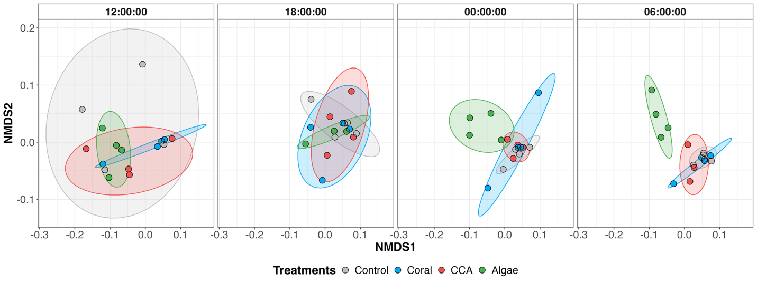
Figure 5: NMDS plots of bacterial communities by treatment across four sampling time points.
Each variable column shows time over 24h passing from left to right, starting at 12:00 until 06:00. Control, coral and CCA communities show similar community composition, while the algae-enriched microbial community structure diverges over time. (NMDS stress = 0.123).

Bacterial communities were further examined at the genus level to determine an association between benthic composition and microbial community structure. We were specifically interested in variations of relative abundance in bacterial taxa across mesocosm treatments and over the four sampling time points in chronological order (Figure 6). Taxa were split into three modules (modules A, B and C) via k-means which grouped taxa with similar patterns of enrichment and depletion. Module A is dominated by Synechococcus (mean 15.1%), SAR11 Clade Ia (mean 2.3%), and Prochlorococcus (mean 2.2%), representing oligotrophic oceanic taxa, while Module B is dominated by HIMB11 (mean 6.8%), Neptuniibacter (mean 2.4%) and Vibrionaceae (mean 1.1%), generally copiotrophic coastal taxa. While all three Modules changed significantly over time and displayed significant time:treatment interactions, Modules A and B additionally showed significant treatment effects, with a significant depletion of taxa in Module A and enrichment of taxa in Module B in the macroalgae-enriched mesocosm communities (Figure 7).

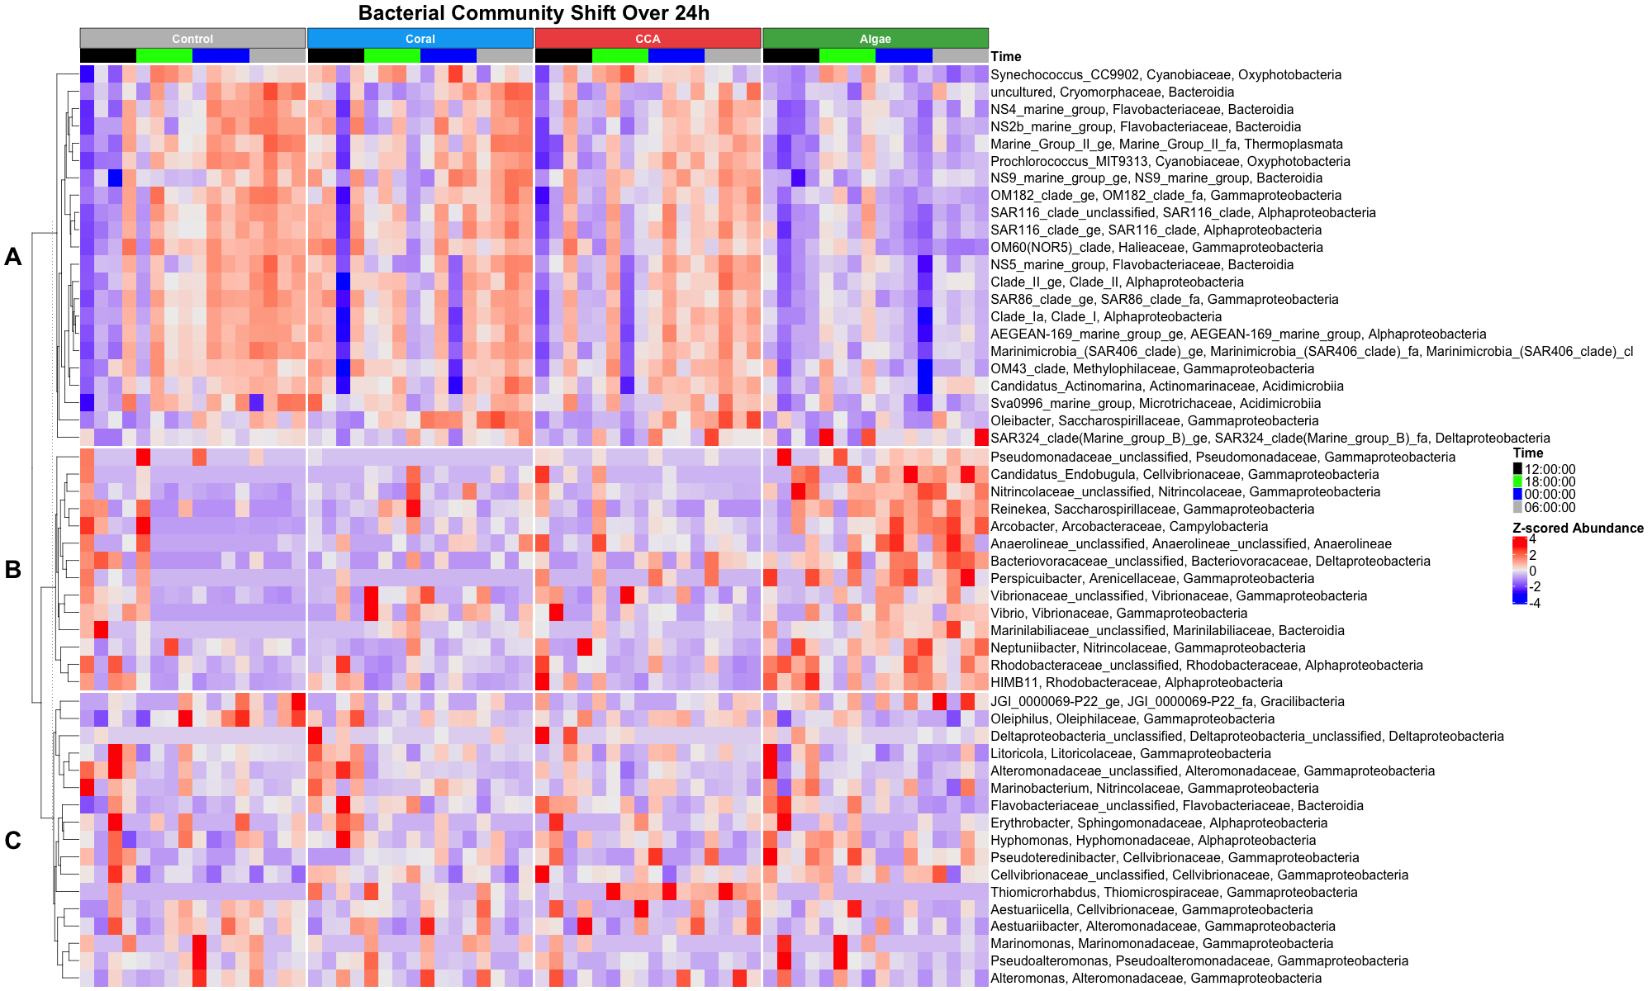
Figure 6: Heatmap showing significant differences in bacterial families across treatment.
Bacteria genera with similar enrichment patterns were clustered in the same module. Three modules can be observed: module A shows bacteria enriched in controls, coral, CCA-enriched treatments, module B shows bacteria enriched in algae-enriched treatments, module C shows microbes that do not have a treatment preference.
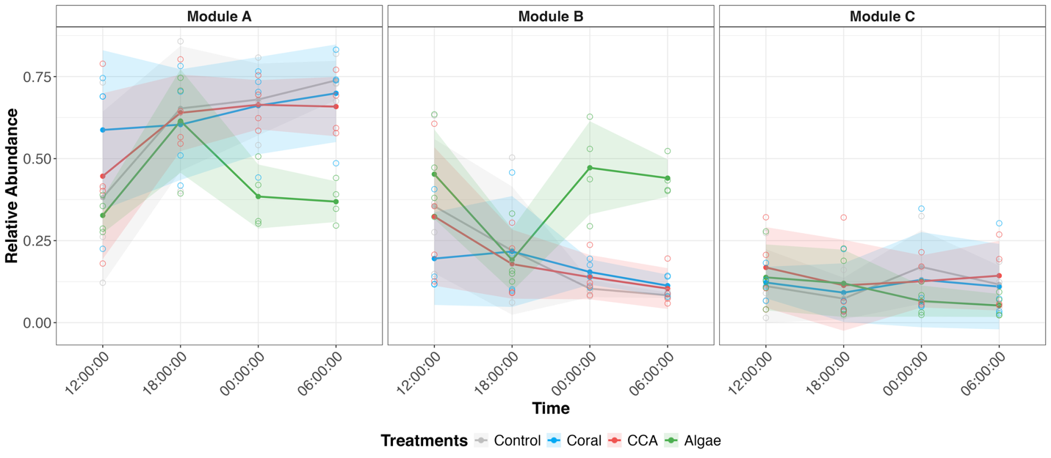
Figure 7: Modules
The relative abundance of bacterial genera were agregated by module and by treatment. Relative abundance curves show depletion of module A microbes and an enrichement of module B microbes in algae-enriched treatments.

The relative abundance of bacterial genera was relativized to the average inflow value at each time point to model enrichment and depletion patterns in each treatment. 23 bacterial genera showed significant treatment effect (p_{treatment} <0.05). Among those 23 genera, 15 genera exhibited significant Dunett’s post-hoc contrasts between control and treatments, specifically in algae-enriched treatments. As a result, algae treatment were associated with the significant enrichment of six genera and the depletion of nine genera (p<0.05) (Table ANOVA). Specifically, within Module A, the most abundant taxa were Synechococcus (mean 15.1%), SAR11 Clade Ia (mean 2.3%), SAR86 (mean 2.2%) and Procholorococcus (mean 2.2%). Of the 22 prevalent genera assigned to Module A, six were significantly depleted in the algae-treatment relative to the control. These key taxa have experienced a decrease from the controls by the end of the 24h sampling: SAR116 (-1.9%), SAR406 (-0.57%), OM182 (-0.34%), OM60 (-1.4%), Prochlorococcus (-1.9%), and Marine Group II genus (-4.5%) (Figure 6). On the other hands, among the 14 taxa assigned to Module B, three were significantly enriched in algae-enriched communities compare the the controls at the end of the 24h experiment: HIMB11 (+4.10%), Nitrincolaceae_unclassified (+4.01%), and Candidatus endobugula (+0.38%). Collectively, the results suggest that bacterial community structure diverges from the controls when benthic communities are enriched in macroalgae.

Discussion
Coral-algal phase shifts associated with coral reef degradation have been hypothesized to induce microbialization in coastal tropical ecosystems (Haas et al., 2016). In this study, we aimed to characterize the coupled inorganic and organic chemical transformations between benthic communities and the water column, as well as microbial community structure in response to biogeochemical stimuli from realistic benthic assemblages from a system undergoing phase shifts. Mixed benthic communities were associated with divergent nutrient consumption, exudate composition and microbial abundance. Additionally, algal enrichment strongly influenced the composition of bacterial community structure in our experiments.

Benthic Community Composition Drives Treatment-Associated Patterns of Organic Exudation and Bacterial Community Structure
Algae enrichment in benthic communities may reduce coral access to essential nutrients. Nitrate is a required nutrient for primary production and roughlly follows the redfield ratio to ensure proper carbon fixation in the marine environment. Our study suggests with robust evidence that algal enrichment in benthic communities is associated with a depletion of the nitrate pool in coral reefs. The time variations of nitrate showed lower concentration during the day, consistent with photosynthetic acitvity in coral reefs, and enrichement during the night, when the system is net heterotrophic suggesting the possible remineralization of organic nitrogen. The treatement associated depletion of nitrate by algae-enriched communities suggests an increase competition for limiting nutrients which may strain corals and prevent their ability to photosynthesis. Dissolved silicate exhibited moderate evidence that CCA communities depleted the nutrient. However, this pattern seem to be driven by differences taken at the being of our experiment (12:00) when the more staggering differences could be observed. It is possible that water column processes could have been occuring and drew down silicate concentration. As such, the silicate depletion observed is not associated with benthic assemblages but is confounded by alternative processes. Lastly, ammonium and phosphate appeared to be decoupled from benthic processes, suggesting that they are not limiting nutrients in benthic primary production. Additionally, evidence suggest that algae DOM are more saccharine than coral DOM, which result in the remineralization of algal DOM into non-bioavailable nutrient forms (CITE – Unsure about this claim).

Organic Exudation and Composition are Driven by Benthic Community Assemblages
Our mesocom expriment expands the results from single organismal exudations to mixed communties, and provide better control over potential confounding factors that may occur in environmental surveys. Our results show visible differences in the composition of coral and macroalgal exometabolomes with algae-enriched assemblages exhibiting a preferential exudation of humic-like compounds which is consistent with results from isolated algal exudation experiments (Quinlan et al., 2018; Wegley Kelly et al., 2021). Unlike those previous studies we did not observe an enrichment in proteinaceous fDOM in coral-associated treatments, suggesting that the mixed assemblages may have dampened that signal through rapid recycling of proteinaceous compounds. Additionally previous studies were able to resolve that macroalgae releasing DOM enriched in specific carbohydrates (Nelson et al., 2013; Thobor et al., 2024), prenol lipids, benzenoids and heterocyclic compounds (Quinlan et al., 2025; Wegley Kelly et al., 2021). The scope of our methodologies lacks the resolution that targeted and untargeted mass spectrometry provide in analyzing exudated organic compounds (Quinlan et al., 2025; Weber et al., 2022; Wegley Kelly et al., 2021). Future iteration of this experiment may include metabolomic surveys as they provide invaluable insight on the interactions between benthic components. Exometabolome have been involved in allelopathy and coral-algae competitive interaction, with implication on coral microbiome alteration, tissue degradation, and coral mortality (Barott et al., 2012; Morrow et al., 2012; Rasher & Hay, 2010; Smith et al., 2006). Nonetheless, because our community exudation results recapitulate and/or are consistent with more reductive single-organism exudation profiles conducted in this same ecosystem (Haas et al., 2011, 2013; Nelson et al., 2013; Wegley Kelly et al., 2021), this experiment reinforces interpretation of dissolved organic matter distribution patterns across these coral reefs (John et al., 2025; Silbiger et al., 2025) (Silbiger 2025, John 2025) as being significantly influenced by benthic exudation and thus responsive to changes in benthic cover.

Composition of Organic Exudates Driven Microbial Community Structure
Microbial community structure associated with algae-enriched treatments shifted strongly over the 4 time points and was significantly different than the seawater control within 12h of initiation of the experiment. This finding is consistent with previous incubation experiments where coral and algal exudates were associated with distinct microbial communities (Haas et al., 2011; Nelson et al., 2013). Additionally, algal exudates have been associated with greater microbial metabolic activity (oxygen demand) but less eﬀicient growth rate (carbon yield) (Haas et al., 2011; Nelson et al., 2013; Thobor et al., 2024). Our results and environmental surveys seem to indicate similar conclusions as algae-dominated reefs not only exhibited elevated heterotrophic bacteria abundance, but were specifically depleted in oligotrophic genera of bacteria, demonstrating shift towards copiotrophic bacterial taxa (Dinsdale et al., 2008; Haas et al., 2016). In place of oligotrophic genera, algal enrichment was associated with bacterial genera in the families Rhodobacteraceae which have been widely reported enriched on algal exudates (Nelson et al., 2013; Quinlan et al., 2025; Weber et al., 2022), and Nitrincolaceae and Cellvibrionadaceae which have been detected in coral microbiome under stress conditions such as hypoxia, disease or heat stress (Howard et al., 2023; Montaño-Salazar et al., 2023; Sparagon et al., 2024). As such our results reinforce that algal exudates restructure bacterial communities away from oligotrophic specialists. As such, in mesocosms, ecologically-relevant enrichments in algal dominance in mixed benthic communities can reproduce observations in DOM and microbial communities predicted by microbialization, including increased humic DOM, bacterioplankton abundance and copiotrophic bacterioplankton taxa. The results of this experiment represent an important experimental validation of some of the predictions of the microbialization hypothesis in degraded reef conditions (Nelson et al., 2023; Silveira et al., 2017).

Time scales
Over the course our diel incubation, with an effective sampling over 18h, we were able to observe exudations differences and the restructuring of microbial communities as a response to benthic community composition. The exudation period is on par with previous incubation period with range from a few hours to up to 48h (Nelson et al., 2013; Sparagon et al., 2024; Wegley Kelly et al., 2021). Results of our experiment reached similar conclusion suggesting a comparable continuity to the current literature. Microbial communities were analyzed over a comparatively short time span as some previous work have incubated their microbial communities on benthic exudate for up to 4 days (Thobor et al., 2024). Although our results did find similar patterns of enrichment, there were differences in the taxa that were identified as enrched and depleted. It is possible that the short incubation periods was not able to capture all taxa that would have changed. Indeed, some oligotrophic, such at SAR 11, have long incubation periods whcihc would not be able to be capture over a diel cycle. As such, a short incubation time may explain why the coral-enriched communities remain comparable to the controls. Longer incubation experiment may allow us the same taxa as the other incuabtion studies like families X, Y,Z . Compared to ecological survey, our bacterial community strucutrre might noit have reached its mature communtiy stability. Indeed, in tropical coral reef microscopic interactions may also impact the bacterial community structure and DOM such as predation, grazing, viral lysis, and competition. These may explain differences with environmentla surveys such as the absence of the families X, Y,Z. Additionally, differences may be specific to different reef systems. Therefore the specific taxonomic enrichment and depletion patterns may diverge due to incubation period, microbiology, and/or ecological factors. However, larger categorization of microbes into copiotrophes and oligotrophes show an overall trend that algae-enriched reefs, typically considered as degraded are still associated with marine copiotrophes.

Conclusion
The preservation of coral reefs is an urgent conservation priority as corals have been steadily declining due to anthropogenic forcings and global climate change. Our findings show that macroalgal enrichment in coral reefs did not change the exudation of bulk DOC but rather altered the composition of organic exudates which was linked to an increase in heterotrophic bacteria abundance, and a decrease in cyanobacteria (Synechococcus). Macroalgal enrichment is also associated with distinct bacterioplankton communities which are depleted of oligotrophic bacterial taxa due to enrichment in copiotrophic bacterial families found under phase shift, heat stress, disease, and/or hypoxic conditions. Developing a mechanistic understanding of coral-algal phase shifts and coral reef microbialization is essential to understand the resilience of coral reefs and their capacity to recover from disturbances, but also to identify coupled systems which may be impacted by biogeochemical changes, e.g., water quality, disease ecology, ecosystem productivity, and food web transfers. Insights from this study are particularly relevant for tropical coastal communities that rely on marine resources for sustenance, cultural practices, and economic development. Understanding the intricacy of microbially mediated processes is an important consideration for the development of management plans at the local level but also for regional and global conservation efforts. Further investigations on the composition of the benthic exudates and the bacterial metabolic pathways involved in the degradation of exudates are necessary to better understand biogeochemical cycling under coral-algal phase shifts worldwide.
Nonetheless, this study represents an important next step toward building controlled mixed community mesocosm models of tropical coral reefs. Results contribute to a mechanistic understanding of bentho-pelagic coupling and the onset of microbialization in tropical coral reefs. Our mesocosms represent a simplified subset of coral reef communities in Mo’orea and additional benthic constituents should be accounted for to establish a comprehensive profile of tropical reef exudation and their contribution to coral reef microbialization. Specifically, turf algae were identified as large contributors to the DOC exudation pool in mesocosm experiments and increase in abundance in degraded reef conditions (Haas et al., 2011; Mueller et al., 2022; Palmer et al., 2025).

References
3) explain how changes in the DOM and the microbes translate to a shift in the ecosystem, articulate the importance of microbial growth efficiency or trophic transfer efficiency. Ex: framing the shift toward copiotrophic taxa as a shift toward a reduced efficiency of recycling DOM exudate Carbon into higher trophic levels because of the inefficient growth of these taxa on these compounds.

[As an aside, the "microbialization" concept as originally framed does not actually incorporate trophic transfer efficiency explicitly: it is more about a shift in the biomass of a reef away from fish and toward microbes: McDole et al. 2012 is where this is most clearly spelled out. I personally think that stocks of biomass a la McDole et al are a poor representation of food web structure in any system, and the efficiency concept is more accurate and captures flux concepts into the hypothesis, so I encourage you to present microbialization as this shift toward less efficient trophic transfer of DOM up the food chain because of inefficient (but rapid) growth by copiotrophs...this is spelled out in the "Yield vs. Power" concept, where microbes have to tradeoff between growth rates (power = copiotrophs = Maserati) and growth yield (efficiency = oligotrophs = Prius). We think coral-dominated reefs are more efficient which helps them persist, and propose that this is driven by more complex DOM and microbes that are more efficient at consuming that DOM.]

5) Discussion: Exploring the literature for evidence from, in the parlance of this work, beakers, mesocosms and surveys.
- Are your results from mesocosms matching what has been shown in beakers? Surveys? Are there any comparable mesocosm results that your work corroborates or refutes?
- For every result (nitrate drawdown, bacterial enrichment, DOM compositional shifts, bacterial community shifts) this should be explored so you can point to where and when your results are consistent with the predictions from the literature, and more importantly where they extend and lend support for observations from more limited beaker or survey work, because that is the real gold to emphasize.
- Just as an anecdote, your observation that a small shift in algal cover can engender a wholesale enrichment in copiotrophic taxa within 24h in a complex community mesocosm with taxa that resemble those observed in both global surveys (Haas et al. 2016) and beaker experiments (Haas et al. 2013, Nelson et al. 2013) gives real creedence to a hypothesis that I had considered pretty shaky until you showed this work. You are making me believe my own BS! ;)

7) Lean in on the graphics where you collapsed the data across all 4 timepoints, and move the diel 4-panel figures to the supplement. This is because you tended to use the diel figures primarily to emphasize consistency of response, and only secondarily to show diel trends, so the supplement seems fine for this, and a single figure in aggregate is far easier to digest (as long as it is statistically appropriate a la Nyssa). Nyssa recommended you add post hoc test connected letters to these graphs, and also advocated that you "stack" them into a single figure. I might suggest "things that go up in algae on the left, things that go down in algae on the right", and each one maybe 3-5 parameters with a common categorical treatment x-axis.

8) We advocated labeling the "0" point on each plot with the mean inflow value in raw units. This can be presented also in the results, and is important for parameters where you discuss (see Nyssa's previous comments below) how big a change is but more importantly what the ambient values actually are and how much they change in units that people understand.
9) Nyssa emphasized that you should present and discuss non-significant data, such as chlorophyll.
10) For the chlorophyll, it would be worthwhile relating chlorophyll to your various phytoplankton cell counts from FCM (syn, pro, picoeuks) to be able to talk about what the chlorophyll is measuring and interpret it (x=syn, y=chl). Also, you can relate your FCM data to the 16S data (x=FCM.syn, y=16S.Syn....same for Pro) to be able to argue whether, for example, the decline in Pro in the 16S data corresponds to a decline in the abundance of Pro...if so then you can interpret relative abundances as though they were absolute abundances, but if not, then it is more likely only a relative shift, and you can interpret the increase in Module A as adding copiotrophs and decrease in Module B as no change in oligotrophs (ie the copiotrophs are growing which the oligotrophs are staying stable).

Can submit to fancier journal if we present it as a mesocosm-based validation of the microbialization hypothesis.

Supplemental Material

Table 1: ANOVA Results of Nutrient Delta

Table 2: ANOVA Results of Square root-transformed OTU relative abundance

Table 3: Dunnett's Post-hoc contrasts square root transformed OTU relative abundance

Table 4: ANOVA Results of Delta Relativized OTU relative abundance

Table 5: Dunnett's Post-hoc contrasts delta relativized OTU relative abundance

Table 6: ANOVA Results of Square root-transformed Genus relative abundance

Table 7: Dunnett's Post-hoc contrasts Square-root transformed Genus relative abundance with signficant ANOVA

Table 8: ANOVA Results of Delta Relativized Genus Relative Abundance

Table 9: Dunnett's Post-hoc contrasts delta relativized Genus relative abundance

